Data Coupling

📌 Definition:
# Source: AI Source: Provided by: [Data Path: Persons Table -> ID Column: 1, Name_En Column: Motasem Essam] -> From: [Chatgpt (GPT‑5 Mini)] on [12/9/2025]
Data Coupling occurs when modules communicate by passing only the data they actually need, usually through parameters or arguments.

🧠 Simple idea:
# Source: AI Source: Provided by: [Data Path: Persons Table -> ID Column: 1, Name_En Column: Motasem Essam] -> From: [Chatgpt (GPT‑5 Mini)] on [12/9/2025]
“Modules share only what’s necessary” ✅

🔍 Key characteristics:
# Source: AI Source: Provided by: [Data Path: Persons Table -> ID Column: 1, Name_En Column: Motasem Essam] -> From: [Chatgpt (GPT‑5 Mini)] on [12/9/2025]
- ✅ Modules are minimally dependent
- ✅ Improves maintainability and clarity
- ✅ Promotes modularity and reusability
- ⚙️ Considered the loosest and most desirable form of coupling

📊 Example of Data Coupling (Good Practice):
# Source: AI Source: Provided by: [Data Path: Persons Table -> ID Column: 1, Name_En Column: Motasem Essam] -> From: [Chatgpt (GPT‑5 Mini)] on [12/9/2025]
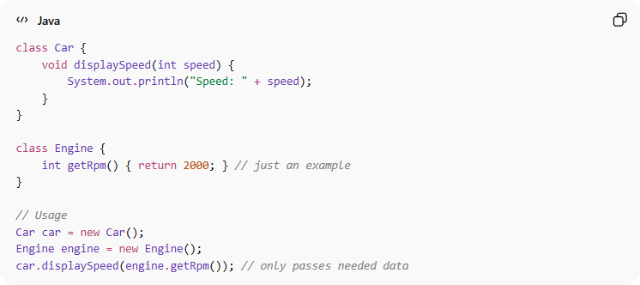
class Car {
void displaySpeed(int speed) {
System.out.println("Speed: " + speed);
}
}

class Engine {
int getRpm() { return 2000; } // just an example
}

// Usage
Car car = new Car();
Engine engine = new Engine();
car.displaySpeed(engine.getRpm()); // only passes needed data
- ✅ Car receives only the RPM value
- ✅ No extra data or structure is shared
- ✅ Modules remain independent and easy to maintain

Data Coupling doesn’t usually have a “bad practice” example is because it is inherently the best form of coupling.

⚙️ Best Practice:
# Source: AI Source: Provided by: [Data Path: Persons Table -> ID Column: 1, Name_En Column: Motasem Essam] -> From: [Chatgpt (GPT‑5 Mini)] on [12/9/2025]
- Pass only the necessary values between modules
- Avoid global data, flags, or entire structures unless required
- Keep module interfaces minimal
- Promotes loose coupling and high cohesion

